

MKT3014 ENTREPRENEURSHIP

Topic:
Individual Assignment - Feasibility Study
Classical Music Café

Prepared by:
Rachel Teh En Lin (14019822)

Date of submission:
22th April 2016

Lecturer:
Dr. Choy Tuck Yun
Table of Content
Title Page No.
- Introduction -------------------------------------------------------- 3
- Product/service feasibility analysis -------------------------------------------------------- 3
  - Product/Service desirability ----------------------------------------------------- 3~4
  - Product/Service demand -------------------------------------------------------- 4
- Industry/Target market feasibility -------------------------------------------------------- 4
  - Industry attractiveness -------------------------------------------------------- 4
  - Target/Market attractiveness ----------------------------------------------------- 4~5
- Organizational feasibility -------------------------------------------------------- 5
  - Management Prowess -------------------------------------------------------- 5
  - Resource Sufficiency ----------------------------------------------------- 6~7
- Financial feasibility ---------------------------------------------------------7
  - Economics of the business ---------------------------------------------------- 7~11
  - Financial Performance of similar businesses -------------------------------- 11~12
  - Overall financial attractiveness of the proposed venture ----------------------- 13
- Conclusion ---------------------------------------------------------------------------------- 13
References ----------------------------------------------------------------------------- 14~15

- Introduction
This feasibility report will assess the overall appeal of the proposed Classical Music Café. The café will sell western food and beverage, environment of the café will be surrounded by classical music played on spot by professional musicians. The store will be located at Bukit Bintang.
Four key sub-analyses are presented in the following sections. Overall, the result of this feasibility analysis is favourable.
- Product/service feasibility analysis
The overall appeal of Classical Music Café is discussed in two sub-sections.
  - Product/Service desirability

A concept test showed that Classical Music Café is viable because the food and beverage will set at an affordable price. Unlike it competitor, Greyhound’s Café, where customer stated it is overpriced (Jocelyn, 2016).

Compared to its competitor, VCR Café (closed at 11pm daily) (Burpple, 2016), Classical Music Café will have longer operating hours from 10am to 12am on weekdays. During weekends, it will close at 1am. Customers nowadays demand for longer operating hours (Ramaswamy & Ozcan 2014).

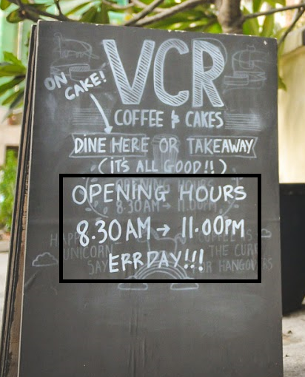

Lastly, classical music will be played live in the café. This is the special features of this café. None of it competitors have do this before. Musicians will take shift to play live classical music.
  - Product/Service demand
A buying intention survey is being conducted around Bukit Bintang and it shows a high demand towards this concept café. For people who enjoy listening to music, 70% of them would visit the café. Customers are also very concern about the price. A reasonable price is demanded by customers.
Gumshoe research is done where the team manage to visit Lepaq Lepaq Café located at Bukit Bintang. The team had the opportunity to talk to the owner and he showed favour about this new concept. He assure that this is a workable idea that can be bring out to the market.
- Industry/Target market feasibility
The overall appeal of the café industry and the target market of Classical Music Café is discussed in the next two sub-sections.
  - Industry attractiveness
The coffee shop industry is a fragmented industry and a near-perfect competitive market because there are many rivals, many customers, low costs of entry and exit (Hill & Jones 2011). It is a growing industry and in the early life cycle because recent years, the trend of café hopping is rising in Malaysia (Cafeculture.com, 2013). It is believed to have a high operating margin as the industry Average Sales per Transaction is 12.95 (US$), which is second only to pizza’s industry. Hence, this shows that the industry has less financial risk (Agr.gc.ca, 2015).
  - Target/Market attractiveness
The main target market for Classical Music Café are young adults around Bukit Bintang as the purchasing power among them is constantly growing. Consumers who visit cafés are mostly from medium to high income groups. These groups of consumers are less price-conscious and have sophisticated tastes (Euromonitor International, 2015). Besides that, this café will also focus on people who enjoy music and has a taste for classical music.
The secondary target market will be workers who work nearby Bukit Bintang (such as Jalan Raja Chulan and Jalan Imbi). The workers or bosses may have meetings at the café, as café would provide them a more relax setting (Hong 2013).
- Organizational feasibility
The next two sub-sections will discuss the non-financial resources of Classical Music Café.
  - Management Prowess
The Classical Music Café is majority-owned by Ms. Rachel and Mr. Danny.
Ms. Rachel holds a Bachelor's Degree in Business Studies. She worked several years for Vees Marketing Sdn Bhd as a marketing consultant. Besides, she also finish her Grade 8 piano and violin which is certified by ABRSM. She had her private music school but two years ago, she sold it profitably.
Mr. Danny has a Bachelor's Degree in Management. He worked as a manager in Prego KL for five years. He also works as part time pianist in La Bodega Restaurant.
The founder is passionate about starting a music café because she has strong interest in music. Research has shown that background music helps improves mood and reduces stress (Bradley 2015). Besides, statistic indicated that 80% of people like to hear background music when they eat out (Daniel 2015).

  - Resource Sufficiency
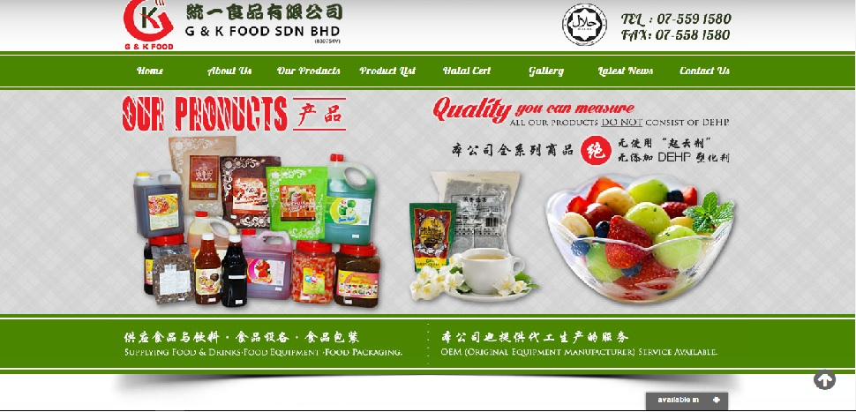
The food and beverage provided in the café will be supplied by G & K Food Sdn Bhd. Two permanent baristas and a chef will be responsible of them.
(Gkfood.com.my, 2016)
An antique piano will be sponsored by Ms. Rachel from her previous music school. Ms Rachel, Mr Danny as well as the other two hired pianist will take shift playing classical music. Customers that are highly skilled in playing piano are also allowed to perform in the café.
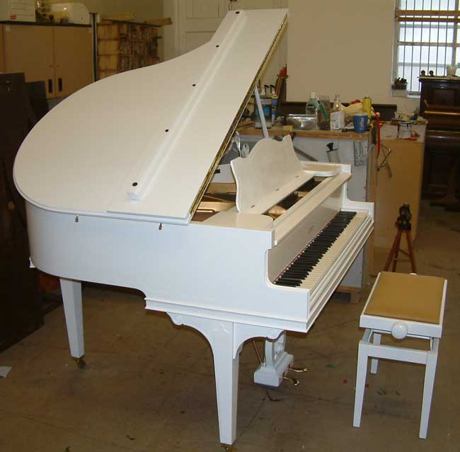

(Sponsored Piano)

Self-service is conducted in this café and customers are allowed to pay using cash only at the counter. A skilled manager will supervise all the procedures. His/her duties include handling the workers, ordering stock and more.
Facebook will be the main site that the café use to communicate with the customers. Statistic shows that 45.5% of the population in Malaysia are Facebook user (Mahadi 2013).
- Financial feasibility
A preliminary financial assessment of Classical Music Café is discussed in the next three sections.
  - Economics of the business
Calculation of Start-up Costs, Cash Flow and Profits for a cash retail business
Forecast (end of month) | 0 | 1 | 2 | 3 | 4
Cash INflow: Cash Sales (1) |  | 35,000 | 40,000 | 45,000 | 50,000
Returnable Deposits | 5,000
Renovation | 100,000
Furniture & Fittings | 18,000
Equipment (Kitchen equipment + Machines) | 70,000
Tax & License - Business registration fees (RM60)  - Solicitor’s fees (RM3,000)  - Domain name registration (RM100)  - Licences and permits (RM150 for food license)  - Food handling certificates (RM 150) | 3,460
Pre-Operation expenses (advertising, etc) - logo (RM380) - website (RM499) - brochures (RM515 for 500 A3 double-sided brochures) - business cards (RM73 for 500 pieces) - signage (RM5,000) - newspapers (RM2,000) | 8,467
Pre-Operation stocks (Food+Beverage ingredients) | 10,000
Others (Franchise fees etc) | -
Start-up costs: | 214,927

Forecast (end of month) | 0 | 1 | 2 | 3 | 4
Operating expenses:
Employee salaries |  | 10,000 | 10,000 | 10,000 | 10,000
Rent |  | 9,000 | 9,000 | 9,000 | 9,000
Utilities (telephone, electricity, water etc) |  | 4,000 | 4,000 | 4,000 | 4,000
Transport (musicians transport fee allowance) |  | 1,500 | 1,500 | 1,500 | 1,500
Insurance |  | 750 | 750 | 750 | 750
Advertising & Promotions |  | 1,200 | 1,200 | 1,200 | 1,200
Maintenance & Upkeep |  | 1,500 | 1,500 | 1,500 | 1,500
Interest payable |  | - | - | - | -
Other expenses |  | - | - | - | -
Total operating expenses (10 items) (3) |  | 27,950 | 27,950 | 27,950 | 27,950
Cash OUTflow: (Expenses + Purchases) | -214,927 | 37,950 | 37,950 | 37,950 | 37,950
Net Cash position | -214,927 | -217,877 | -215,827 | -208,777 | -196,727

Forecast (end of month) | 0 | 1 | 2 | 3 | 4
Calculation of profits
Cash Sales (1) |  | 35,000 | 40,000 | 45,000 | 50,000
Less: Cost of sales
Purchases (2) |  | 10,000 | 10,000 | 10,000 | 10,000
Gross Profit |  | 25,000 | 30,000 | 35,000 | 40,000
Less Total operating expenses (3) |  | 27,950 | 27,950 | 27,950 | 27,950
Net Operating Profit |  | -2,950 | 2,050 | 7,050 | 12,050

Additional Information:
Estimated Cash Sales and Purchases Cost
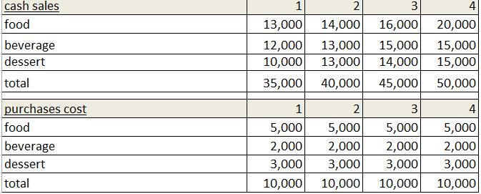

Rental (Iproperty.com.my, 2016)
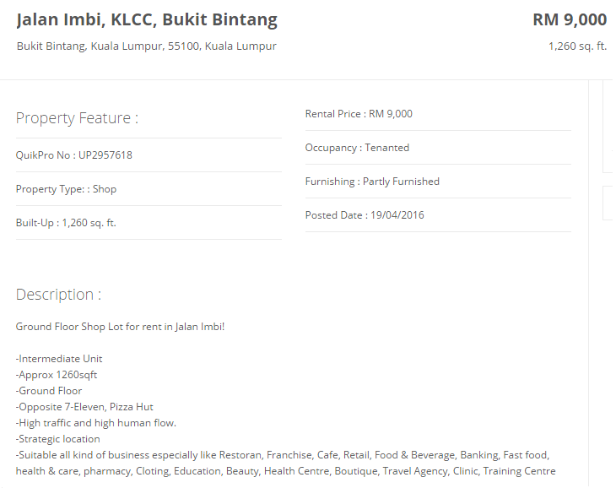

Pre-operation costs:
Newspaper cost
Website cost
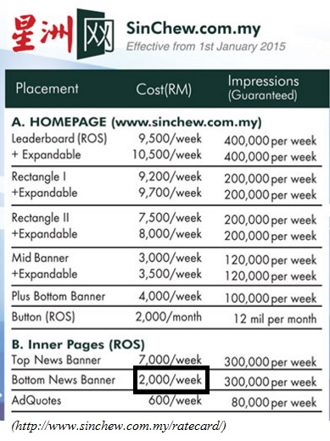


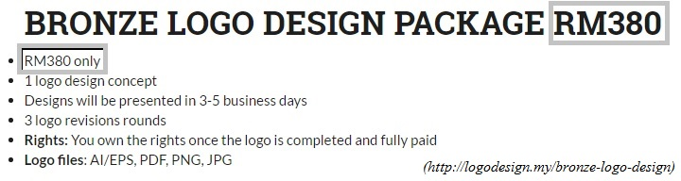
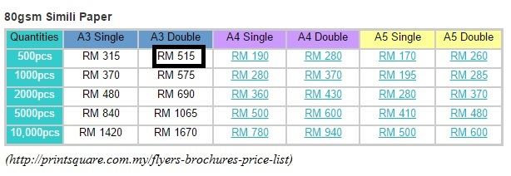
Logo cost
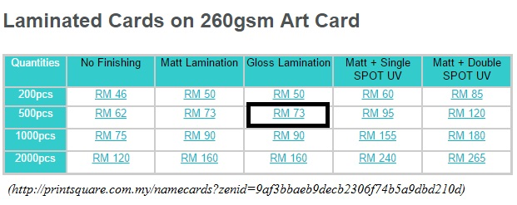
Business Card Cost
Brochures cost
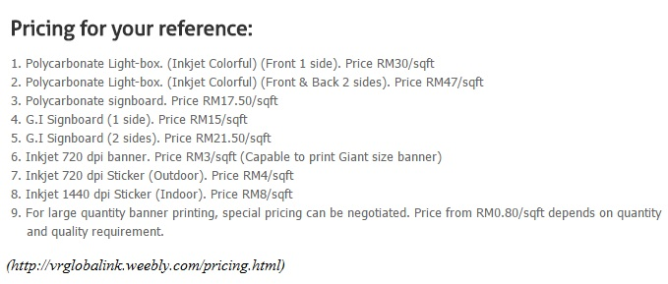
Signage cost

The major revenue drivers are the western food, beverage and desserts. The gross sales are RM 35,000 for first month and expected to grow RM5,000 each month. Although the price is going to set at a reasonable price, it is projected that customers would return after their first try. Besides, positive word-of-mouth will attract more customers (Bejou & Palmer 2013). The cost of goods sold are RM10,000 each month. Hence, the gross profit for the forecasted months will be RM25,000, RM30,000, RM35,000 and RM40,000.
After deducting the total operating expenses, a loss of RM2,950 will incurred at the first month. In the following months, the net operating profit is estimated to grow.
  - Financial Performance of similar businesses
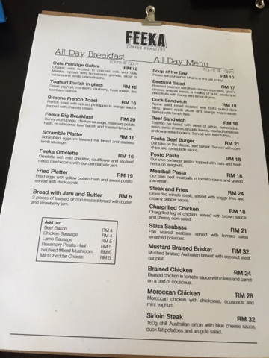
Compared to Feeka Coffee Roasters located at Bukit Bintang, their meals’ price is priced at the range of RM12 to RM32, having an average of RM18 for a dish. Besides, their average beverage price is RM10 for a drinks. Desserts such as cakes are being priced around RM11 to RM13.

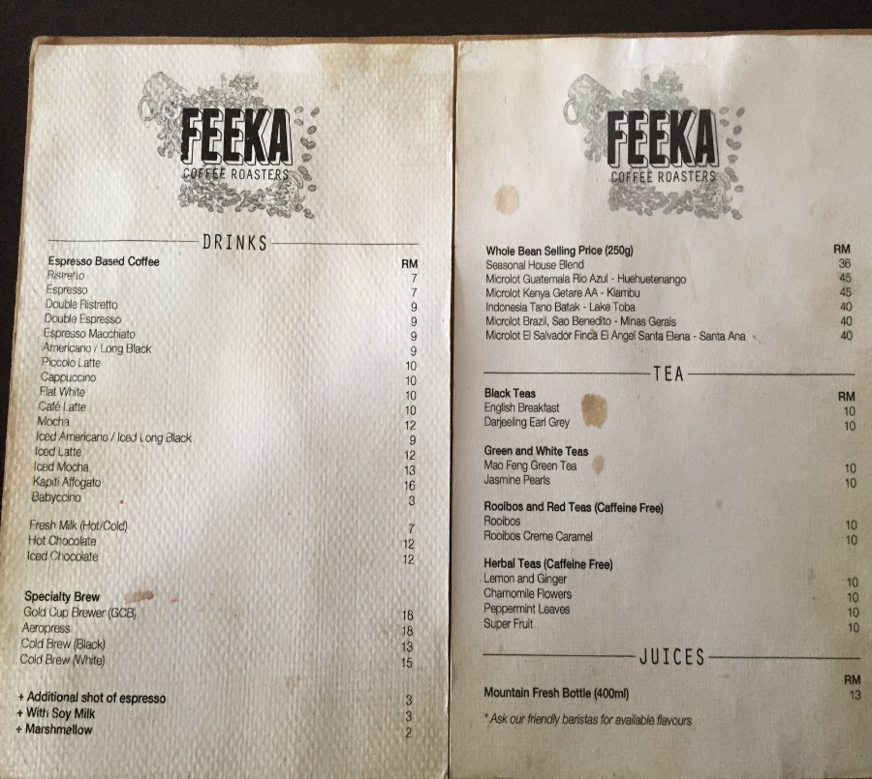

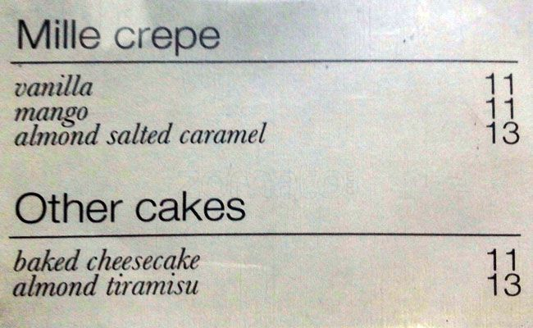

A gumshoe research is being conducted. The team visited Feeka Coffee Roasters and interviewed the manager. He mentioned that the average cost of ordering the food and beverage are around RM12,000. Also, he indicated that the café highest sales for a month could reach RM40,000, especially during holiday and festival seasons.

  - Overall financial attractiveness of the proposed venture
Classical Music Café is financially attractive as the overall forecast income and expenses could be determined with a reasonable degree of certainty. There may be some losses at first due to people is still new to the café, but it is believed that the profits will grow after months.
Besides, this café has high novelty concept which is expected to boost the café industry. Classical Music Café is likely to move away from novelty and attained a unique existence with a natural audience. The team have the strength to move beyond form into substance.
- Conclusion
This report shows that Classical Music Café is feasible due to its uniqueness that is not found in the market yet. It is believed to bring the café industry to a higher level and customers who are interested in classical music would enjoy a lot. Besides the music, delicious food and beverage in the café is going to fascinate customers.
1110 words

References
Agr.gc.ca. (2015). Foodservice Profile - Malaysia - Agriculture and Agri-Food Canada (AAFC). [online] Available at:
http://www.agr.gc.ca/eng/industry-markets-and-trade/statistics-and-market-information/by-region/southeast-asia/foodservice-profile-malaysia/?id=1418754135558 [Accessed 19 Apr. 2016].
Bradley, D., 2015. Why restaurants play music while you eat. Available at: http://phys.org/news/2015-09-restaurants-music.html [Accessed April 9, 2016].
Bejou, D. & Palmer, A., 2013. The Future of Relationship Marketing, Routledge. Available at: https://books.google.com/books?id=OrAuAgAAQBAJ&pgis=1 [Accessed April 14, 2016].
Billboard Advertisement Malaysia. (2016). Pricing. [online] Available at: http://vrglobalink.weebly.com/pricing.html [Accessed 21 Apr. 2016].
Daniel, 2015. The Subliminal Effects of Music in Restaurants. Available at: http://www.jesrestaurantequipment.com/jesrestaurantequipmentblog/music-that-makes-you-want-to-eat-the-effects-of-music-in-restaurants/ [Accessed April 9, 2016].
Hill, C.W.L. & Jones, G.R., 2011. Essentials of Strategic Management, Cengage Learning. Available at: https://books.google.com/books?id=VdG243upAqwC&pgis=1 [Accessed April 8, 2016].
Hong, C., 2013. Café hopping: A growing trend. Available at: http://www.businesscircle.com.my/cafe-hopping-growing-trend/ [Accessed April 8, 2016].
Jocelyn, 2016. Greyhound Café. Available at: http://www.timeout.com/kuala-lumpur/restaurants/greyhound-cafe#tab_panel_3.
Logo Design. [online] Available at: http://logodesign.my/bronze-logo-design [Accessed 21 Apr. 2016].

Mahadi, N., 2013. 13.3 million M’sians are Facebook users – BorneoPost Online | Borneo , Malaysia, Sarawak Daily News | Largest English Daily In Borneo. Borneo Post Online. Available at: http://www.theborneopost.com/2013/06/16/13-3-million-msians-are-facebook-users/ [Accessed April 10, 2016].
Malaysia Online Logo Designs | Malaysian Logo Designer Since 1999. (2015). BRONZE
Printsquare.com.my. (2016). Flyers / Brochures Price List. [online] Available at: http://printsquare.com.my/flyers-brochures-price-list [Accessed 21 Apr. 2016].
Printsquare.com.my. (2016). Namecard Printing. [online] Available at: http://printsquare.com.my/namecards?zenid=9af3bbaeb9decb2306f74b5a9dbd210d [Accessed 21 Apr. 2016].
Ramaswamy, V. & Ozcan, K., 2014. The Co-Creation Paradigm, Stanford University Press. Available at: https://books.google.com/books?id=Zhf1AgAAQBAJ&pgis=1 [Accessed April 11, 2016].
Sinchew.com.my. (2016). 廣告價格表 | Rate Card. [online] Available at: http://www.sinchew.com.my/ratecard/ [Accessed 21 Apr. 2016].
TheMalaysian.com. (2016). Web Design Malaysia. [online] Available at: http://www.themalaysian.com/web-design-malaysia [Accessed 21 Apr. 2016].

